**PRACTICAL 5 : Temperature on LCD**

**Aim :** To interface a 16x2 LCD with Arduino and display temperature readings.

**Overview :**

In this project, a temperature sensor is interfaced with an Arduino and a 16x2 LCD to display real-time temperature readings. This practical helps in learning about LCD interfacing, data communication between components, and the importance of real-time monitoring in IoT systems.

**Materials Required :**

* Arduino Uno R3
* 1 x 220 Ω Resistor
* LCD 16x2
* Temperature Sensor (TMP36)
* Jumper Wires
* Arduino IDE (Installed on your Computer)

**Circuit Connection and Steps :**

1. **Connect the TMP36 Temperature Sensor :**
   * VCC → 5V, GND → GND, VOUT → A5 (Arduino).
2. **Connect the 16x2 LCD Display :**
   * RS → D7, E → D8, D4-D7 → D9-D12 (Arduino).
   * VSS, RW, K → GND, VDD, A → 5V.
   * V0 → Potentiometer (Middle Pin) for contrast control.
3. **Connect the Potentiometer:**
   * One side → 5V, Other side → GND, Middle → V0 (LCD).
4. **Power Connections:**
   * 5V → Positive Rail, GND → Negative Rail on Breadboard.

**Circuit Diagram :**

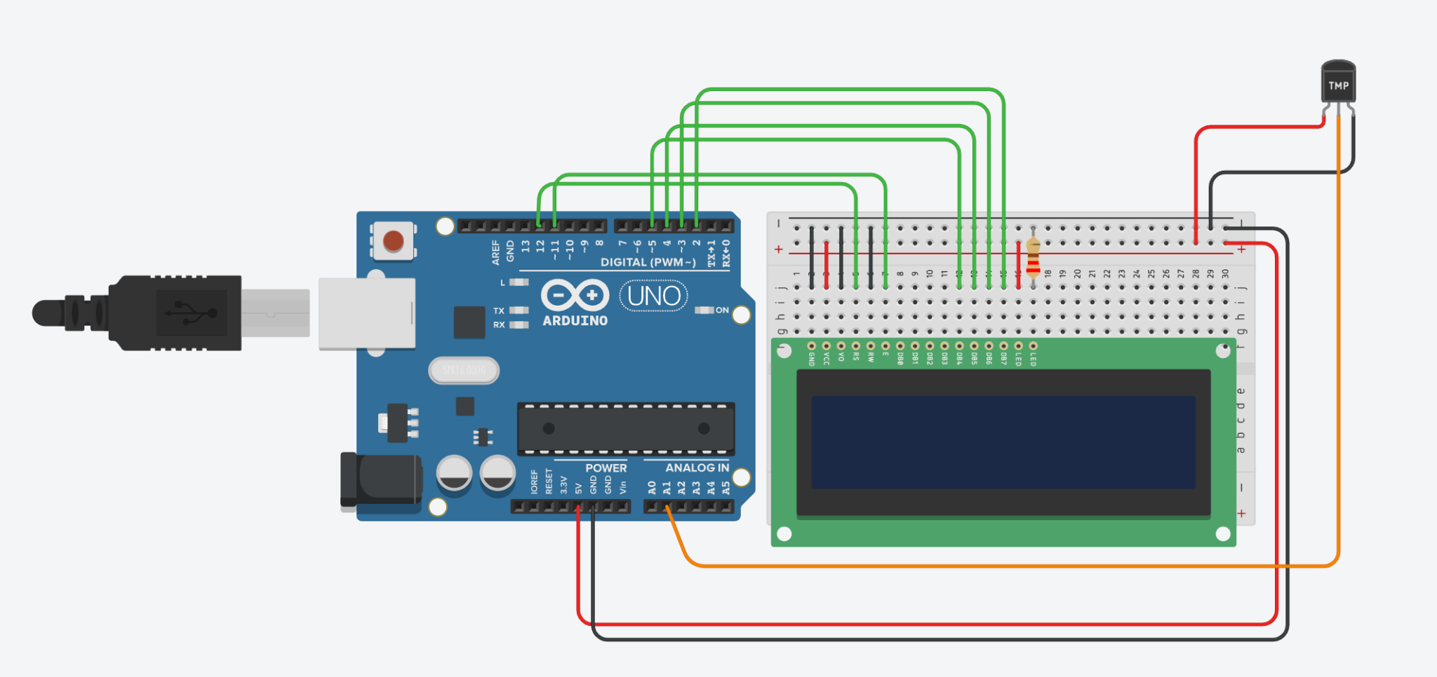

**Schematic Diagram :**

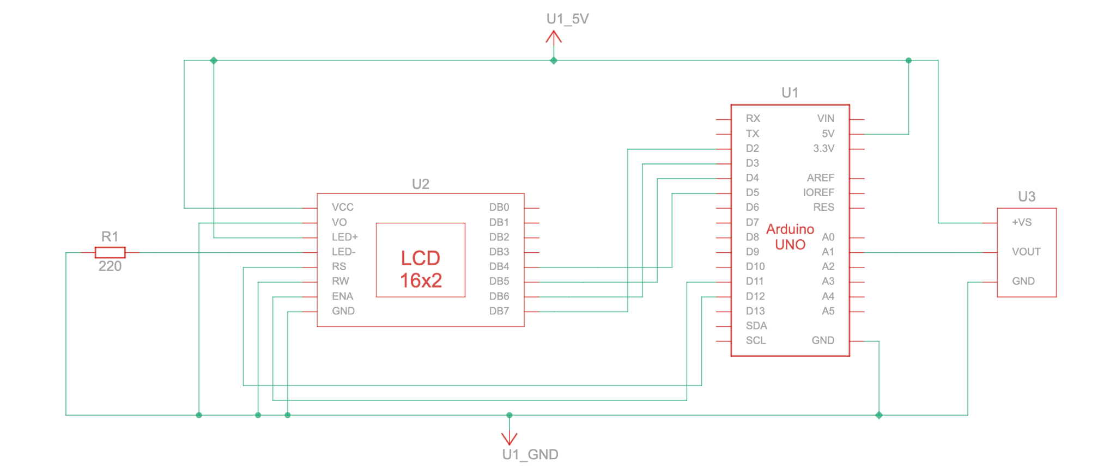

**Code :**

#include<LiquidCrystal.h>

const int rs = 12, en = 11, d4 = 5, d5 = 4, d6 = 3, d7 = 2;

LiquidCrystal lcd(rs, en, d4, d5, d6, d7);

float celsius;

int temp = A1;

void setup(){

pinMode(temp,INPUT);

}

void loop(){

celsius = analogRead(temp)*0.004882814;

celsius = (celsius - 0.5) * 100.0;

lcd.setCursor(0,1);

lcd.print("--> Temp : ");

lcd.print(celsius);

lcd.print(" C");

delay(1000);

lcd.clear();

}

**Results :**

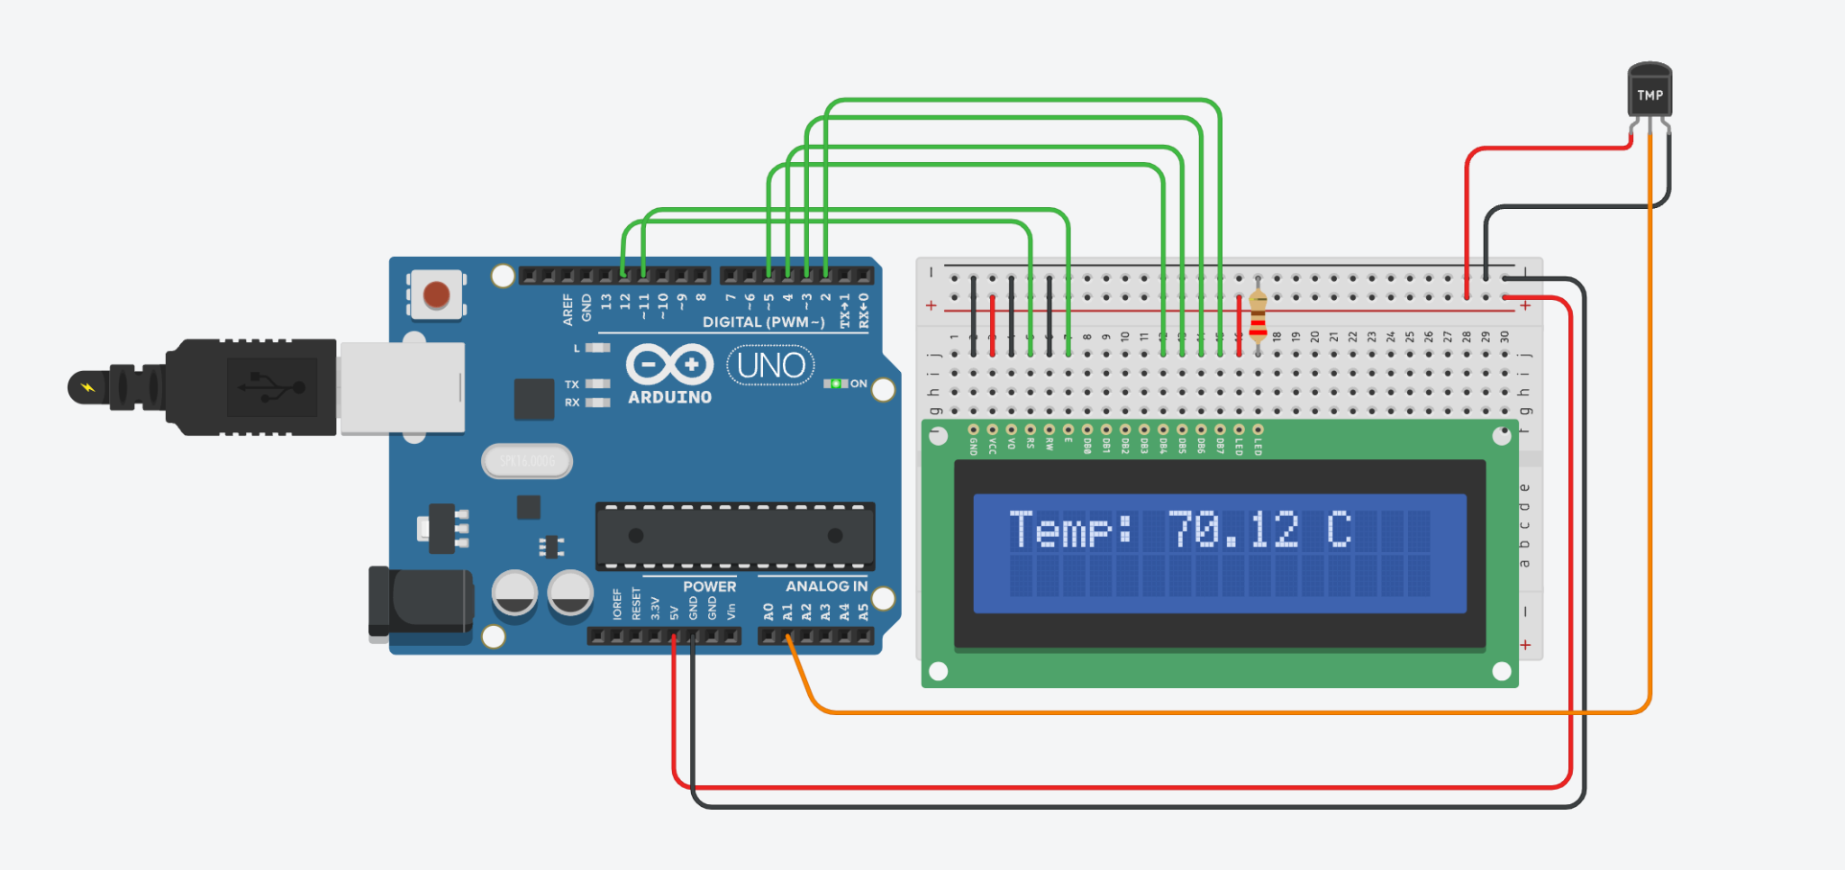

**Conclusion :**

This project successfully demonstrates how to interface a 16x2 LCD with an Arduino to display real-time temperature readings. It reinforces the concepts of sensor integration and data visualization, providing a crucial step toward developing more complex IoT applications involving real-time monitoring systems.